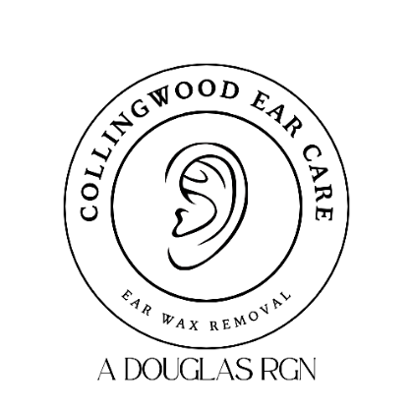

Complaints Policy and Procedure

1. Policy Statement
Collingwood Ear Care is committed to providing safe, effective, and high-quality ear irrigation services in clients’ homes. We welcome feedback and view complaints as an opportunity to learn, improve, and maintain high standards of care.
We aim to ensure that all complaints are handled promptly, fairly, transparently, and in accordance with regulatory requirements.

2. Scope
This policy applies to:
- All clients receiving services from Collingwood Ear Care
- Family members, carers, or representatives acting on a client’s behalf
- All staff and contractors providing services
It covers complaints relating to:
- Clinical care or treatment
- Service delivery
- Communication
- Staff conduct
- Administrative processes
- Any other aspect of our services

3. Principles
We will ensure that:
- Complaints are taken seriously and treated respectfully
- Clients are not treated differently because they have made a complaint
- The complaints process is accessible and easy to use
- Responses are honest, clear, and timely
- Lessons learned are used to improve services.
4. How to Make a Complaint
Clients or their representatives can raise a concern or complaint through the following channels:
Verbal Complaint
Raised directly with the attending nurse or any member of staff.
Written Complaint
Email: collingwoodearcare@outlook.com
Post:
40 Collingwood Drive
Hexham
NE46 2JA
Telephone Complaint
07716 451597
If required, we will provide reasonable assistance to individuals who need help making a complaint.

5. Complaint Handling Process
1. Acknowledgement
All complaints will be acknowledged within 2 working days of receipt.
2. Investigation
A senior member of staff will investigate the complaint. This may involve reviewing clinical records, speaking with staff involved, and clarifying details with the complainant.
3. Response and Resolution
A written response will be provided within 10 working days. If the investigation requires more time, the complainant will be informed of the reason and given a revised timeframe.
The response will include:
- A summary of the complaint
- Findings of the investigation
- Any actions taken or proposed
- An apology where appropriate

4. Escalation
If the complainant is dissatisfied with the outcome, they may request a further review by:
Joanne Robson
Independent Complaint Handler
07943 019584
If the matter remains unresolved, complainants may contact the Care Quality Commission (CQC). Please note that the CQC does not investigate individual complaints but may use information provided to inform regulatory activity.

6. Confidentiality and Record Keeping
All complaints will be handled confidentially and in accordance with data protection legislation.
Records of complaints, investigations, and outcomes will be securely stored and retained in line with regulatory requirements.

7. Learning and Continuous Improvement
Collingwood Ear Care will:
- Maintain a complaints log
- Review complaints periodically to identify trends
- Implement service improvements where necessary
- Share learning outcomes with staff where appropriate

Date: 04 February 2025 – Amended 05 March 2025
Reviewed 13 February 2026
Signed: A Douglas
Review date: February 2027

